**Setup of UR5e Robot Arm**

1. **ROS2 Humble and Moveit2 ( Ubuntu 22.04 )**

<https://docs.ros.org/en/humble/Installation/Ubuntu-Install-Debs.html>

<https://moveit.picknik.ai/humble/doc/tutorials/getting_started/getting_started.html>

1. **UR5e Robot drivers**

<https://github.com/UniversalRobots/Universal_Robots_ROS2_Driver/tree/humble>

<https://docs.ros.org/en/ros2_packages/humble/api/ur_robot_driver/doc/usage.html>

1. **Femto Bolt ROS2 Packages**

[**https://github.com/orbbec/OrbbecSDK_ROS2**](https://github.com/orbbec/OrbbecSDK_ROS2)

1. **For Calibration**

<https://github.com/giuschio/ros2_handeye_calibration?tab=readme-ov-file>

[**https://github.com/christianrauch/apriltag_ros**](https://github.com/christianrauch/apriltag_ros)

1. **Python scripting for moveit using ROS2 humble ( Native python scripting is available only from ROS2 Rolling onwards)**

[**https://github.com/AndrejOrsula/pymoveit2**](https://github.com/AndrejOrsula/pymoveit2)

**USAGE and Workflow**

1. **Start up the robot**

ros2 launch ur_robot_driver ur_control.launch.py ur_type:=ur5e robot_ip:=192.168.56.101

Start external program on Polyscope

ros2 launch ur_moveit_config ur_moveit.launch.py ur_type:=ur5e launch_rviz:=false

You can now control the robot with moveit

/opt/ros/humble/share/ur_description/urdf/ur_macro.xacro

To change tool0 location ^

1. **Startup camera and visualize**

ros2 launch orbbec_camera femto_bolt.launch.py

Use rviz2 and add respective topics of color image, depth image, ir image or pointcloud to view it in rviz

1. **Calibration - In Progress**

ros2 run apriltag_ros apriltag_node --ros-args -r image_rect:=/camera/color/image_raw -r camera_info:=/camera/color/camera_info --params-file /home/panasonic/ros2_ws/src/apriltag_ros/cfg/tags_36h11.yaml  
  
realsense -

ros2 run apriltag_ros apriltag_node --ros-args -r image_rect:=/camera/camera/color/image_raw -r camera_info:=/camera/camera/color/camera_info --params-file /home/panasonic/ros2_ws/src/apriltag_ros/cfg/tags_36h11.yaml

Above command is for April tag detection. Make sure to change the tags_36h11.yaml file according to the size of your tag

Then the commands below are for the calibration node and then triggering the service for taking the samples

ros2 launch hand_eye_calibration calibration.launch.py

ros2 service call /hand_eye_calibration/capture_point std_srvs/srv/Trigger {}

This will provide you with the calibration matrix for transforming images in the camera frame to robot base_link frame

1. **PyMoveit2**

ros2 run pymoveit2 ex_pose_goal.py --ros-args -p position:="[-0.8890,0.2984,0.200]" -p quat_xyzw:="[0.2643,0.9642,0.0161,-0.0137]" -p cartesian:=True

Above is a sample command that can be used for a end effector position that has been found after using the calibration matrix. There are other examples available in the pymoveit2 repo that can be used, but ex_pose_goal.py is what is currently being used.

ros2 run tf2_ros static_transform_publisher 0.00 0.00 0.15 0 0 0 1 wrist_3_link tool0

ros2 run tf2_ros tf2_echo base_link tool0_controller

ros2 run tf2_ros tf2_echo camera_color_optical_frame tag36h11:0

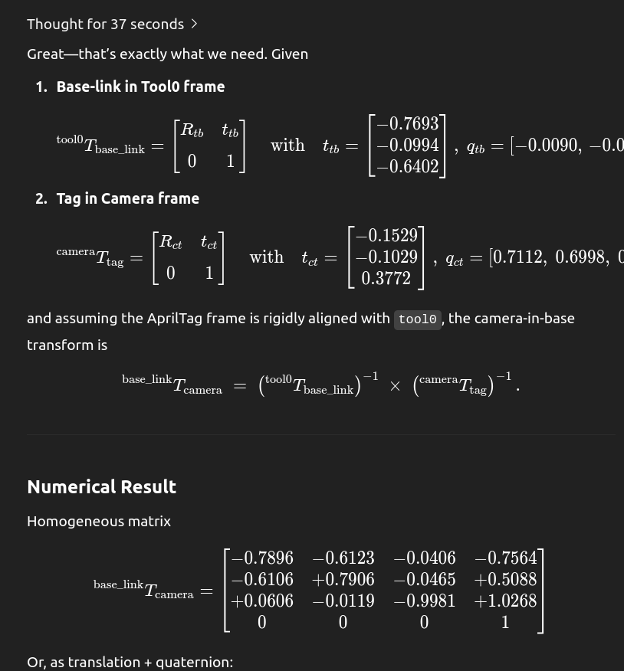

**June 19th**

1. **Memory -**
2. **Prompts -** Change prompts in prompt file to specify direction in your real world
3. Change env file to ur specific robot

Planners available  
  
BKPIECEkConfigDefault ESTkConfigDefault KPIECEkConfigDefault LBKPIECEkConfigDefault PRMkConfigDefault PRMstarkConfigDefault RRTConnectkConfigDefault RRTkConfigDefault RRTstarkConfigDefault SBLkConfigDefault TRRTkConfigDefault

**Running voxposer envbridge**

ros2 launch ur_robot_driver ur_control.launch.py ur_type:=ur5e robot_ip:=192.168.56.101 kinematics_params_file:=/home/panasonic/robot_calibration.yaml

ros2 launch ur_moveit_config ur_moveit.launch.py ur_type:=ur5e

ros2 launch moveit_control_pkg standalone_tcp_pose_server.launch.py ur_type:=ur5e use_cartesian:=true

ros2 run tf2_ros static_transform_publisher -0.67450 0.68198 0.95908 0.92211 0.38370 0.03602 0.03441 base_link camera_color_optical_frame

ros2 run tf2_ros tf2_echo base_link tool0

**ros2 run pymoveit2 voxposer_moveit.py**

python3 script/ur5_envbridge_retry_savemem_v1.py 2>&1 | tee log_envbridge.txt

**Running KUDA**

export PYTHONPATH=$HOME/pyorbbecsdk/build/install/lib:$PYTHONPATH

ros2 run moveit_control_pkg tcp_pose_server_kuda --ros-args -p use_cartesian:=false^C

(kudaoriginal) panasonic@panasonic-All-Series:~/KUDA$ echo $CUDA_HOME

/home/panasonic/anaconda3/envs/kudaoriginal/pkgs/cuda-toolkit

**CALIBRATION -**

1. Overhead realsense d455

ros2 run tf2_ros static_transform_publisher -0.65929 0.72136 0.85829 -0.37775 0.91128 -0.14943 0.06750 base_link camera_color_optical_frame

17th July

ros2 run tf2_ros static_transform_publisher -0.49387 0.59460 0.89782 -0.37936 0.92398 -0.04728 0.01018 base_link camera_color_optical_frame

1. Overhead Orbbec camera

ros2 run tf2_ros static_transform_publisher

-0.61242 0.61839 0.86175

0.91209 0.40958 0.01703 0.00664

base_link camera_color_optical_frame

1. Wrist camera

ros2 run tf2_ros static_transform_publisher

0.016543 0.089023 -0.163985

-0.004787 0.025668 -0.997618 0.063852

tool0 camera_color_optical_frame

1. Side Realsense camera

ros2 run tf2_ros static_transform_publisher

-0.85868 0.80047 0.29923

-0.33570 0.80193 -0.45527 0.19220

base_link camera_color_optical_frame

ros2 run tf2_ros static_transform_publisher -0.99265 0.72944 0.35029 -0.35501 0.84646 -0.37527 0.12901 base_link camera_color_optical_frame

planner_configs:

SBLkConfigDefault:

type: geometric::SBL

longest_valid_segment_fraction: 0.001

projection_evaluator: joints(joint_1,joint_2)

range: 10

ESTkConfigDefault:

type: geometric::EST

longest_valid_segment_fraction: 0.001

projection_evaluator: joints(joint_1,joint_2)

range: 10

goal_bias: 0.05

LBKPIECEkConfigDefault:

type: geometric::LBKPIECE

projection_evaluator: joints(joint_1,joint_2)

longest_valid_segment_fraction: 0.001

range: 10

BKPIECEkConfigDefault:

type: geometric::BKPIECE

projection_evaluator: joints(joint_1,joint_2)

longest_valid_segment_fraction: 0.001

range: 10

KPIECEkConfigDefault:

type: geometric::KPIECE

projection_evaluator: joints(joint_1,joint_2)

longest_valid_segment_fraction: 0.001

range: 10

goal_bias: 0.05

RRTkConfigDefault:

type: geometric::RRT

longest_valid_segment_fraction: 0.001

range: 10

goal_bias: 0.05

RRTConnectkConfigDefault:

type: geometric::RRTConnect

longest_valid_segment_fraction: 0.001

range: 10

RRTstarkConfigDefault:

type: geometric::RRTstar

longest_valid_segment_fraction: 0.001

range: 10

goal_bias: 0.05

TRRTkConfigDefault:

type: geometric::TRRT

longest_valid_segment_fraction: 0.01

range: 10

goal_bias: 0.05

(More available parameters)

PRMkConfigDefault:

type: geometric::PRM

longest_valid_segment_fraction: 0.001

max_nearest_neighbors: 100

PRMstarkConfigDefault:

type: geometric::PRMstar

longest_valid_segment_fraction: 0.001

Description of Parameters

-------------------------Parameters Used in all Planners------------------------------------------

longest_valid_segment_fraction =the resolution at which collisions are checked Posible values- From 0.001 to 1 in 0.001 step

-------------------------Parameters Used in Tree-Based Planners------------------------------------------

Range: Represents the maximum length of a motion to be added to the tree of motions. Posible values- From 0 to 10000 in 1 step

-------------------------Parameters Used in Tree-Based Planners which needs a proyection to work ------------------------------------------

projection_evaluator: Defines the orientation of the projection A good projection in robot arms is the one formed by the shoulder and elbow joints.

-------------------------Parameters Used in Tree-Based Planners with just one tree------------------------------------------

goal_bias: The process of randomly selecting states in the state space to attempt to go towards, the algorithm may in fact choose the actual goal state, if it knows it, with some probability. This probability is a real number between 0.0 and 1.0 with a 0.01 step

-------------------------Parameters Used in Probabilistic Roadmap Planners PRM------------------------------------------

max_nearest_neighbors: represents the maximum number of nodes at which each vertex of the tree can be connected. Posible values- From 8 to 1000 in 1 step

<https://www.traceparts.com/en/search/traceparts-classification-mechanical-components-jig-and-fixture-construction-clamping-clamps-uclamps?CatalogPath=TRACEPARTS%3ATP01007002002008>

<https://www.traceparts.com/en/product/elesa-tru-ushaped-pulling-hooks-for-pulling-hook-clamps-zincplated-steel-ushaped-pulling-hook-trum1046129?CatalogPath=TRACEPARTS%3ATP01007002004006&Product=70-14122020-118298&PartNumber=GG.AX561>

Teleoperation commands

ros2 launch ur_robot_driver ur_control.launch.py ur_type:=ur5e robot_ip:=192.168.56.101 kinematics_params_file:=/home/panasonic/robot_calibration.yaml initial_joint_controller:=forward_velocity_controller

ros2 launch ur_moveit_config ur_moveit.launch.py ur_type:=ur5e launch_servo:=true

ros2 service call /servo_node/start_servo std_srvs/srv/Trigger {}

Possibly have to source ws_moveit first  
  
ros2 launch moveit_control_pkg spacenav_teleop.launch.py

TrackDLO

(hMin = 0 , sMin = 0, vMin = 0), (hMax = 179 , sMax = 255, vMax = 64) - black wire

roslaunch trackdlo realsense_node.launch

roslaunch trackdlo trackdlo.launch num_of_nodes:=25

docker exec -it trackdlo bash

rosrun image_view image_saver image:=/camera/color/image_raw